Given an binary array nums and an integer k, return true *if all* 1*'s are at least* k *places away from each other, otherwise return* false.

**Example 1:**

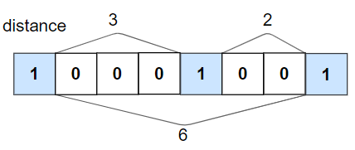

Input: nums = [1,0,0,0,1,0,0,1], k = 2  
Output: true  
Explanation: Each of the 1s are at least 2 places away from each other.

**Example 2:**

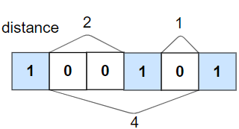

Input: nums = [1,0,0,1,0,1], k = 2  
Output: false  
Explanation: The second 1 and third 1 are only one apart from each other.

**Constraints:**

* 1 <= nums.length <= 105
* 0 <= k <= nums.length
* nums[i] is 0 or 1